KEY TO WALKS AND CYCLE RIDES
Walk Grade | Easy | Moderate | Strenuous
Cycle Ride Grade | Easy | Moderate | Strenuous
IMPORTANT NOTICE | Please arrange your own transport to weekends away – we usually ‘car share’.

PARTICIPATION STATEMENT
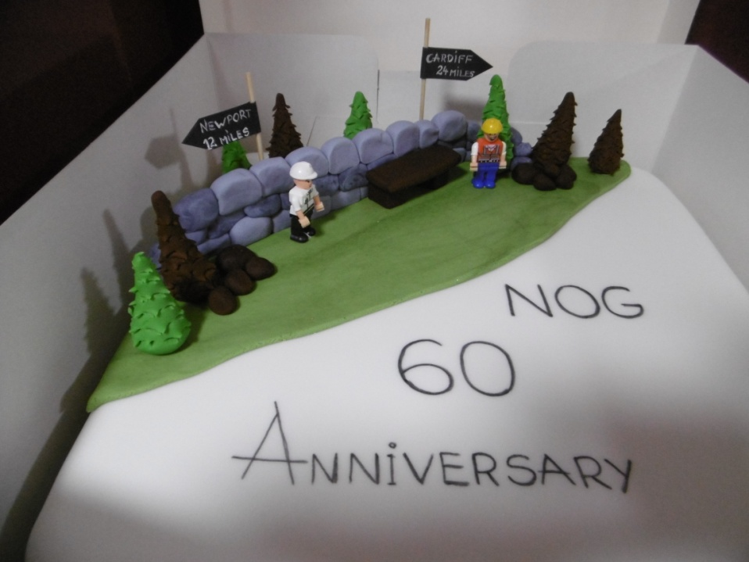
All walks and outdoor activities carry risks of accident or injury. Participants should be aware of and accept these risks and be responsible for their own actions. Participants should also ensure that they are in good health, of sufficient fitness and have the correct clothing and equipment for a particular activity. Any questions – ask a committee member or event leader.

ESSENTIAL EQUIPMENT FOR GROUP WALKS AND WEEKENDS AWAY
- Waterproof jacket and trousers plus warm clothing
- Stout shoes or boots
- Thermal gloves, hat, first aid kit, whistle and survival bag
- Food, drink, map, compass, torch and mobile phone
NB. The tougher, the longer the walk or, if the walk is in the mountains and/or in winter, please bring all or more of the above equipment. Haven’t got all of it ? Ask a committee member or the walk leader beforehand – perhaps you could borrow some.

COMMITTEE MEMBERS
Hostel booking queries | Alan Lucas | 07790721803 / alanrichardlucas@hotmail.com
Programme queries | Dave Fereday | 07879222135 / davefereday@hotmail.co.uk
For other committee members – check the web site.

CHANGES TO THE PROGRAMME.
Occasionally Group events may change. Please listen to announcements at Group events, read e mails sent to you, ask a committee member or check the web site.

PROGRAMME OF EVENTS
JULY 2021

www.newportoutdoorgroup.co.uk

NEWPORT OUTDOOR GROUP (YHA) | EVENTS PROGRAMME | DATE  July 2021

EVENING EVENTS
Date | Time | Event Description | Grade
5th July  Mon | 19.00 | A Bunker and a Castle Chris N shows us a historical WW2 bunker used for the defence of Newport.
12th July  Mon | 19.00 | Cefn Onn Park Walk with Norman along the Rhymney Valley Ridgeway. Top notch views across the Channel as well.
19th July  Mon | 19.00 | Slade Wood Mags and Jeremy take us on a woodland walk near Magor that will take more than a Minett.
26th July  Mon | 19.00 | Ruperra Castle King Ian shows us the second home he’d like to have had.
WEEKEND EVENTS
Date | Time | Event Description | Grade
3rd July  Sat | 10.00 | Clydach and Llanelly Dave F leads us on a 7 mile walk to see the history of the Iron Works followed by the Monmouthshire and Brecon Canal. There is a grave in Llanelly Churchyard of interest to dog lovers. Meet at the car park in Gilwern, NP7 0AJ.
11th July  Sun | 10.30 | Merthyr Mawr Come and explore the underated Glamorgan Coast on an eight mile moderate walk led by Chris H.Parking at Merthyr Mawr Pay and Display car park, CF32 0LS

Thursday Evening Walks

There is a sociable walk most Thursday evening throughout the year.
These walks are around the Newport area and the length is 4 to 4.5 miles, therefore 2 hours duration.
Always meet at the start point which is generally in the vicinity of a pub, so walkers can stay for a social pint after the walk or not.
In the summer the walks are on footpaths and during the winter months they tend to be more urban.

Details of the walk are posted to the NOG Facebook page and NOG Meetup the Sunday before the walk.

